

**Artificial Intelligence and Data Science Department.**

OOPM / Odd Sem 2021-22 / Experiment 10.

**____________________________________________________________**

YASH SARANG.

47 / D6AD.

EXPERIMENT - 10.

**____________________________________________________________**

**AIM / THEORY:**

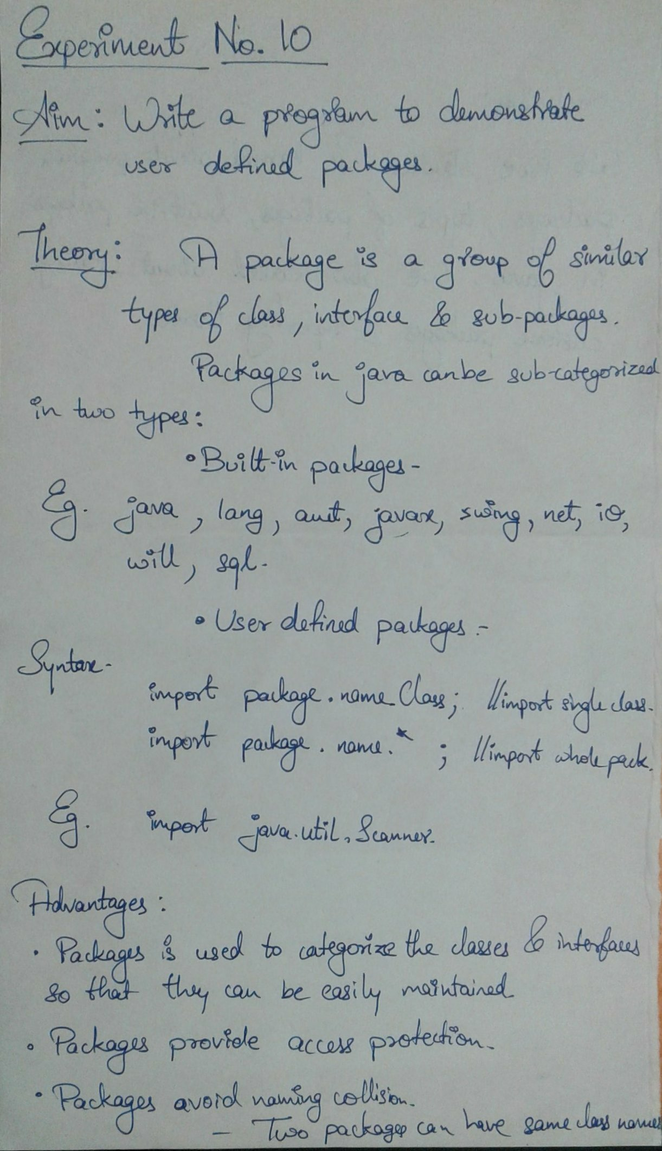

**____________________________________________________________**

**Program 1:**

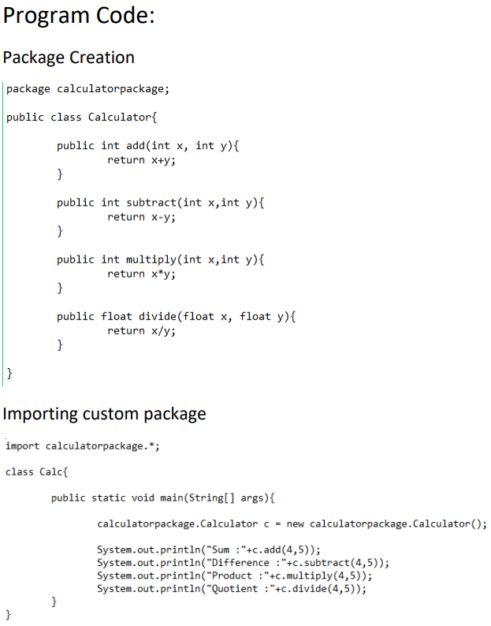

**The output of the program :**



